**Java package->**

*A java package is a group of similar types of classes, interfaces and sub-packages.

*Package in java can be categorized in two form, built-in package and user-defined package.

*There are many built-in packages such as java, lang, awt, javax, swing, net, io, util, sql etc.

**Advantage of Java Package->**

1. Java package is used to categorize the classes and interfaces so that they can be easily maintained.
2. Java package provides access protection.
3. Java package removes naming collision

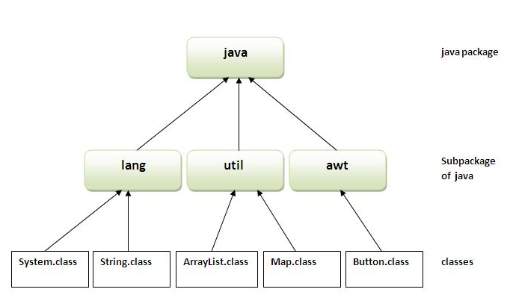

**\*The package keyword is used to create a package in java.**

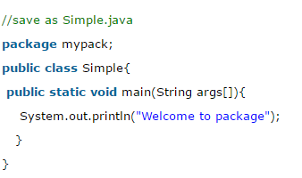

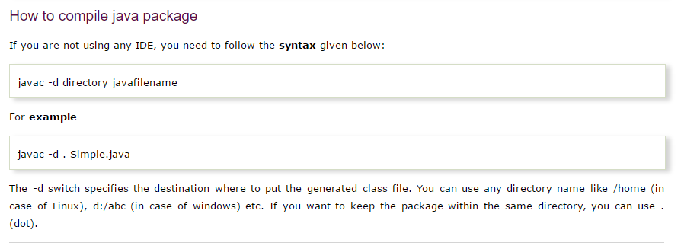

## How to access package from another package?

**There are three ways to access the package from outside the package.**

1. **import package.*;**
2. **import package.classname;**
3. **fully qualified name.**

#### **Using packagename.*->**

**\*If you use package.* then all the classes and interfaces of this package will be accessible but not subpackages.**

**\*The import keyword is used to make the classes and interface of another package accessible to the current package.**

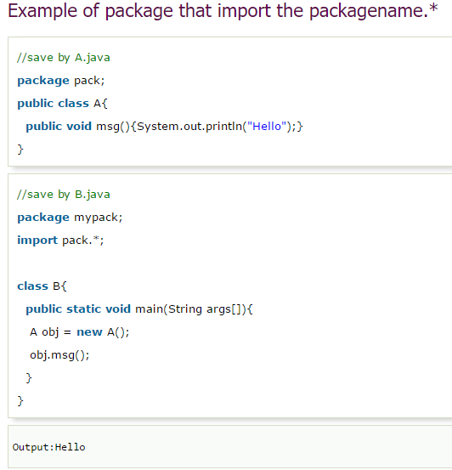

#### **Using packagename.classname->**

**If you import package.classname then only declared class of this package will be accessible.**

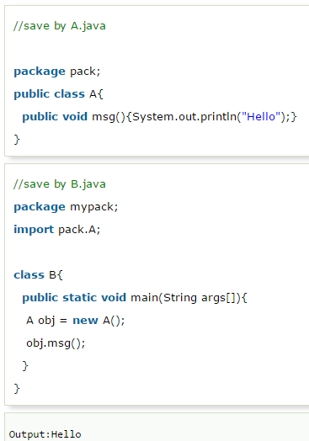

#### **Using fully qualified name->**

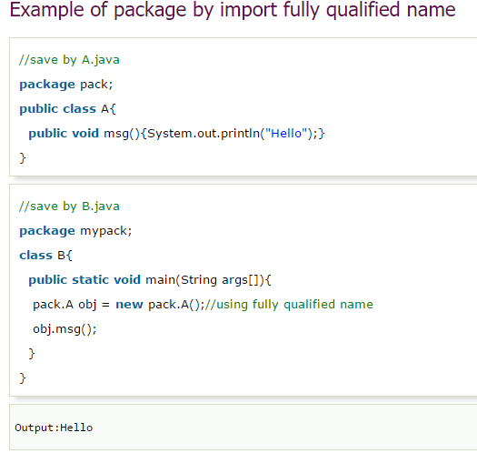

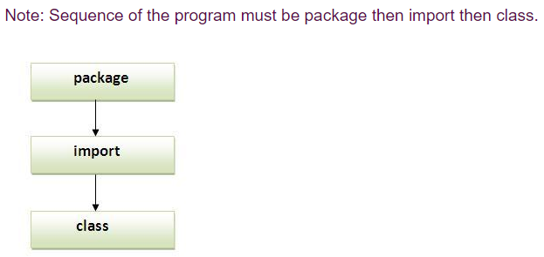

Subpackages in Java->

Package inside the package is called the **subpackage**. It should be created **to categorize the package further**.

*Some time package contain many classes like System ,Reader,String,writer,socket etc. these classes Represent Group.

*some are different in work like for some input/output abd some are for networking so its subcategorized the java package into

*subpackages such as lang,net,io etc.

Ex.

